**ATAR course examination, 2024**

Question/Answer booklet

**YEAR 11 ATAR**

PHYSICAL

EDUCATION

STUDIES

|  |  |  |  |  |  |  |  |  |
| --- | --- | --- | --- | --- | --- | --- | --- | --- |
| WA Student number: In figures |  |  |  |  |  |  |  |  |

In words ___________________________________

_________________________________

**Time allowed for this paper**

Reading time before commencing work: ten minutes

Working time: two and a half hours

**Materials required/recommended for this paper**

***To be provided by the supervisor***

This Question/Answer booklet

***To be provided by the candidate***

Standard items: pens (blue/black preferred), pencils (including coloured), sharpener, correction fluid/tape, eraser, ruler, highlighters

Special Items: Nil

**Important note to candidates**

No other items may be taken into the examination room. It is **your** responsibility to ensure that you do not have any unauthorised material. If you have any unauthorised material with you, hand it to the supervisor **before** reading any further.

**Structure of this paper**

|  |  |  |  |  |  |
| --- | --- | --- | --- | --- | --- |
| Section | Number of  questions  available | Number of  questions to  be answered | Suggested  working time  (minutes) | Marks  available | Percentage  of written  examination |
| Section One Multiple-choice | 20 | 20 | 30 | 20 | 20 |
| Section Two  Short answer | 7 | 7 | 90 | 80 | 50 |
| Section Three Extended answer | 4 | 2 | 60  **Total** | 30 | 30 |
|  |  |  |  | 124 | 100 |

**Instructions to candidates**

1. Write your answers in this Question/Answer booklet preferably using a blue/black pen. Do not use erasable or gel pens.
2. Answer the questions according to the following instructions.

Section One: Answer all questions in the Question/Answer booklet. For each question, circle the letter to indicate your answer. Use only a blue or black pen. If you make a mistake, place a cross through that letter, then circle your new answer. Do not erase or use correction fluid/tape. Marks will not be deducted for incorrect answers. No marks will be given if more than one answer is completed for any question.

Section Two: Write your answers in this Question/Answer booklet. Wherever possible, confine your answers to the line spaces provided.

Section Three: Consists of four (4) questions. You must answer two (2) questions. Write your answers in this Question/Answer booklet.

1. You must be careful to confine your answers to the specific questions asked and to follow any instructions that are specific to a particular question.
2. Supplementary pages for the use of planning/continuing your answer to a question have been provided at the end of this Question/Answer booklet. If you use these pages to continue an answer, indicate at the original answer where the answer is continued, i.e. give the page number.

**Section One: Multiple-choice 20% (20 Marks)**

This section has **20** questions. Answer **all** questions on the Question/Answer booklet. For each question, circle the letter to indicate your answer. Use only a blue or black pen. If you make a mistake, place a cross through that letter, then circle your new answer. Do not erase or use correction fluid/tape. Marks will not be deducted for incorrect answers. No marks will be given if more than one answer is completed for any question.

**Suggested working time: 30 minutes.**

**___________________________________________________________________**

1. To which bone is the origin point of the agonist muscle attached in the eccentric phase of a bicep curl?
   1. fibula
   2. radius
   3. scapula
   4. tibia
2. Adduction of the arm at the shoulder primarily uses which muscle?
3. deltoid
4. latissimus dorsi
5. trapezoid
6. adductor group
7. Which of the following contains the lowest percentage of oxygen saturation?
   1. aorta
   2. pulmonary vein
   3. capillaries within internal organs during exercise
   4. pulmonary artery
8. Which of the following would be the best measure of muscular power?
   1. timed single-leg wall sit
   2. 400 m sprint time
   3. standing vertical jump
   4. 1rm bench press
9. A basketballer going surfing and mountain biking in their off-season is most likely considering which principle of training?
   1. reversibility
   2. specificity
   3. progressive overload
   4. cardiorespiratory endurance
10. During a 30-minute training session, an athlete randomly alternates between bouts of high and low intensity running. This training method is most likely
    1. interval training
    2. speed training
    3. Fartlek training
    4. cardiovascular endurance training
11. Which of the following skills can be classified as being the most gross?
12. writing with a pencil in your PE studies exam
13. bicep curling your maximum weight in front of the mirror
14. getting a hole-in-one in mini golf
15. performing one star jump while carrying no extra weight
16. While practicing a tennis serve your coach adjusts your grip on the racket to enable you to make better contact with the ball. This is an example of which type of cue?
    1. pool
    2. visual
    3. proprioceptive
    4. external
17. Which type of motor skill is the triple jump best described as?
    1. power event
    2. gross skill
    3. open skill
    4. a series of discrete skills
18. Theoretically, a shotput should be released at which angle to maximise distance?
    1. exactly 45 °
    2. slightly below 45 °
    3. slightly above 45 °
    4. exactly 90 °

Use the information below to respond to questions 11 to 13.

The Ultra 5k is a running event where competitors run a 5-kilometre circuit every hour. If they finish the 5k circuit before the hour ends, they can rest until the hour is up. The last runner standing wins.

.

1. If a runner completes each lap in 30 minutes and completes 5 laps before pulling out. Which of the following is correct?
   1. average velocity = 5 km/h
   2. average speed = 20 km/h
   3. average speed = 5 km/h
   4. average velocity = 0 km/h
2. Which of the following would not occur immediately after running the first lap of the Ultra 5k?
   1. increased capillarisation around the alveoli
   2. stroke volume increases
   3. systolic blood pressure is reduced
   4. tidal volume increases
3. At the start of each of the laps in the Ultra 5k, there can often be lots of jostling for position and many runners accidentally knock into others. What advice would you give to a runner to help them stay on their feet while minimising impact on performance?
   1. sprint the first 200 m at 90% intensity to run clear of the other runners
   2. put on an extra 5 kg mass in the lead-up to the race to increase stability
   3. lean into other runners when you know contact is unavoidable
   4. take larger steps in the first section of the race to increase base of support
4. What advice could you give to a rugby player to lower their line of gravity?
   1. bend their knees when expecting contact
   2. increase muscle mass by training in the gym
   3. drive your legs forward when expecting contact
   4. the line of gravity cannot be lowered
5. While taking a penalty kick in soccer, the striker decides to kick to the top right of the net and concentrates on a specific section of the ball they want to contact. Which quadrant of Nideffer’s model would this moment fall under?
   1. broad-external
   2. broad-internal
   3. narrow-external
   4. narrow-internal
6. How does beginner athletes’ concentration compare to elite athletes?
   1. move slowly from broad to narrow concentration
   2. only have narrow concentration
   3. move slowly from internal to external concentration
   4. can only focus on the relevant cues
7. Which type of lever in the human body would an increased range of motion generally have the greatest benefit to performance?
   1. 1st class
   2. 2nd class
   3. 3rd class
   4. all the same
8. You are the coach of a social indoor soccer team and are deciding what to give to the team at halftime. Each half lasts for 15 minutes. Which choice would provide the greatest benefit?
   1. protein shake
   2. pasta
   3. water
   4. energy gel
9. During an archery tournament, an archer watches their first of three arrows hit the target 10 cm above the centre. This is an example of
   1. internal feedback.
   2. concurrent feedback.
   3. external feedback on performance.
   4. non-verbal feedback.
10. Tasks that require high levels of arousal are often
    1. complex
    2. requiring more information processing
    3. gross motor skills
    4. requiring broad attentional focus

**End of Section One**

**Section Two: Short answer 50% (80 Marks)**

This section has **seven** questions. Answer **all** questions. Write your answers in the spaces provided. Supplementary pages for planning/continuing your answers to questions are provided at the end of this Question/Answer booklet. If you use these pages to continue an answer, indicate at the original answer where the answer is continued, i.e. give the page number.

**Suggested working time: 90 minutes.**

**___________________________________________________________________**

**Question 21**  **(10 marks)**

1. Name **three** articulating bones found in the elbow joint. (3 marks)

_________________________________________________________________________________________________________________________________________________________________________________________________________

1. Identify the antagonist muscle involved in extension at the knee. (1 mark)

___________________________________________________________________

1. Describe the concept of antagonistic pairs with reference to the up-phase of a chin-up. (3 marks)

_________________________________________________________________________________________________________________________________________________________________________________________________________

______________________________________________________________________________________________________________________________________

Pictured below is Matilda’s striker Mary Fowler. She was a key factor behind the Matildas’ success during the World Cup.

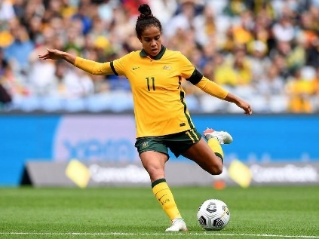

1. Identify the **three** main joint movements involved in the kicking phase when Mary strikes the ball (3 marks)

_________________________________________________________________________________________________________________________________________________________________________________________________________

**Question 22**  **(10 marks)**

1. Outline the path a red blood cell takes from the right atrium to the left atrium. (4 marks)

Enters the right atrium

1. ______________________________________________________________
2. ______________________________________________________________
3. ______________________________________________________________
4. ______________________________________________________________

Enters the left atrium

1. Other than red blood cells, identify the **two** other components of blood and outline their function. (4 marks)

_______________________________________________________________________________________________________________________________________________________________________________________________________________________________________________________________________________________________________________________________________________

1. Outline **two** differences between arteries and veins. (2 marks)

______________________________________________________________________________________________________________________________________

______________________________________________________________________________________________________________________________________

**Question 23**  **(10 marks)**

George is a local amateur touch football player preparing for a tournament on the weekend. The tournament consists of four 30-minute matches being played back-to-back with only a 5-minute rest period in between each game.

1. George understands that nutrition is important, so he eats a large bowl of macaroni and cheese 30 minutes before his first game. Assess George’s choice of nutrition and make **two** recommendations for a more suitable plan. (4 marks)

_________________________________________________________________________________________________________________________________________________________________________________________________________

______________________________________________________________________________________________________________________________________

___________________________________________________________________

1. The coach identifies some flaws in George’s technique and decides to give him some 1-on-1 lessons before the final the next day. Identify **three** types of cues Dan could give George to help improve his touch football skills and provide an example of how each can be used in this situation. (6 marks)

____________________________________________________________________________________________________________________________________________________________________________________________________________________________________________________________________________

______________________________________________________________________________________________________________________________________

_________________________________________________________________________________________________________________________________________________________________________________________________________

**Question 24 (16 marks)**

Badminton is widely regarded as having the fastest projectile of any sport. In 2023 a badminton shuttle smash by Satwiksairaj Rankireddy was measured at 565 km/h. Badminton players require lightning-fast reflexes and need to make decisions in fractions of a second.

1. Discuss the four-step process that a badminton player receiving a serve would undergo as they process information to win the point by identifying and outlining each of the **four** steps, and providing a relevant example of how this happens in this situation. (12 marks)

_______________________________________________________________________________________________________________________________________________________________________________________________________________________________________________________________________________________________________________________________________________

_________________________________________________________________________________________________________________________________________________________________________________________________________

_________________________________________________________________________________________________________________________________________________________________________________________________________

___________________________________________________________________________________________________________________________________________________________________________________________________________________________________________________________________________________________________________________________________________________________________________________________________________________________________________________________________________________________________________________________________________________________________________________________________________________________

1. Describe a difference between gross and fine motor skills and for each provide an example that relates to Badminton. (4 marks)

__________________________________________________________________________________________________________________________________________________________________________________________________________________________________________________________________________________________________________________________________________________________________________________________________________________

**Question 25 (15 marks)**

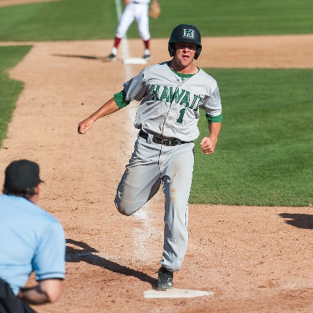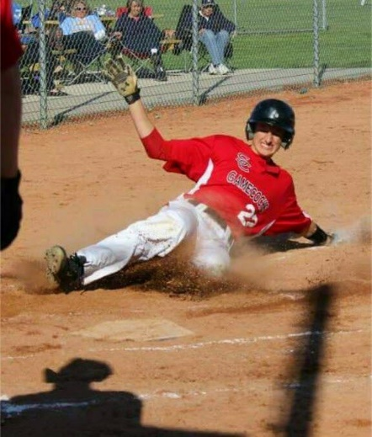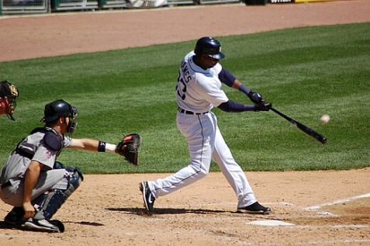

1 2 3

1. Identify the type of motion that would best describe a baseballer in each of the three scenarios. (3 marks)
2. Running between two bases: ____________________________________________
3. The slide into home plate: ____________________________________________
4. Swinging for the ball: ____________________________________________

An experienced batter must decide in a split second where the best place to hit a baseball is. It depends on the pitch, field placement, and stage in the game.

1. Identify **three** variables affecting the projectile motion of the baseball and suggest a way in which batter could alter them. (6 marks)

_____________________________________________________________________________________________________________________________________________________________________________________________________________________________________________________________________________________________________________________________________________________________________________________________________________________________________________________________________________________

______________________________________________________________________________________________________________________________________

1. The fastest ever baseball pitch was clocked in at 170km/h by Aroldis Chapman. On the graph below, draw the optimal timing of the shoulders, wrist, hips, and elbow in order to accelerate the baseball at maximum velocity. (2 marks)

Velocity

Time

1. According to the coordination continuum, what type of movement is occurring in the baseball pitch described above? (1 mark)

___________________________________________________________________

1. Referring to the principles of segmental interaction, what are **three** pieces of advice you could give to someone learning to throw a baseball as fast as possible? (3 marks)

__________________________________________________________________________________________________________________________________________________________________________________________________________________________________________________________________________________________________________________________________________________________________________________________________________________

**Question 26 (8 marks)**

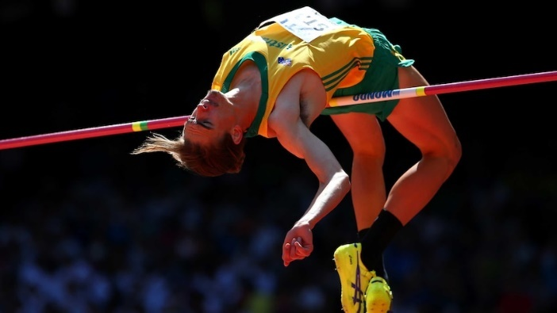Brandon Starc currently holds the Australian high jump record clearing a height of 2.36m. He shares the record with Tim Forsyth who jumped the same height in 1997.

1. Starc can produce a powerful plantar flexion at the ankle. Identify which type of lever is used at the ankle and outline the **three** components that make up this lever. (4 marks)

_______________________________________________________________________________________________________________________________________________________________________________________________________________________________________________________________________________________________________________________________________________

1. During the jump, Starc flicks his head backwards in order to better clear the bar. Identify which type of lever is used for the head flick and outline the **three** components that make up this lever during the high jump action. (4 marks)

_______________________________________________________________________________________________________________________________________________________________________________________________________________________________________________________________________________________________________________________________________________

**Question 27 (11 marks)**

Rohan Browning is currently the fastest Australian over 100m and is representing Australia at the Paris Olympics.

1. Define Newton’s three laws and give an example of how they could relate to Rohan in the 100m sprint. (6 marks)

__________________________________________________________________________________________________________________________________________________________________________________________________________________________________________________________________________________________________________________________________________________________________________________________________________________

_________________________________________________________________________________________________________________________________________________________________________________________________________

1. Which 10m segment of the race would Rohan experience the most and least acceleration? (2 marks)

____________________________________________________________________________________________________________________________________________________________________________________________________________________________________________________________________________

1. Identify where Rohan may position his line of gravity when he is waiting at the starting blocks for the gun and justify why this would be the best position. (3 marks)

_______________________________________________________________________________________________________________________________________________________________________________________________________________________________________________________________________________________________________________________________________________

**Section Three: Extended answer 30% (30 Marks)**

This section contains **four** questions. You must answer **two** questions. Write your answers in the spaces provided. Supplementary pages for planning/continuing your answers to questions are provided at the end of this Question/Answer booklet. If you use these pages to continue an answer, indicate at the original answer where the answer is continued, i.e. give the page number.

**Suggested working time: 60 minutes.**

**_________________________________________________________________________**

**Question 28 (15 marks)**

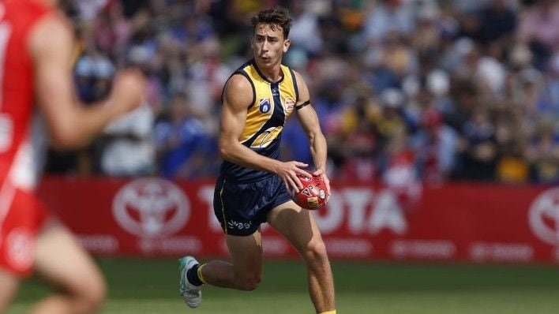Brady Hough is a 22 yr-old defender currently playing for the West Coast Eagles. He started his career in Western Australia in the south-west playing Auskick at the junior level and then attending Australind Senior High School.

1. Name each of the Fitts and Posner phases of motor learning and describe each with reference to how Brady would likely have progressed from first picking up a football, to playing juniors in Australind, to playing in the AFL. (9 marks)

____________________________________________________________________________________________________________________________________________________________________________________________________________________________________________________________________________________________________________________________________________________________________________________________________________________________________________________________________________________________________________________________________________________________________________________________________________________________________________________________________________________________________________________________________________________________________________________________________________________________________

____________________________________________________________________________________________________________________________________________________________________________________________________________________________________________________________________________

____________________________________________________________________________________________________________________________________________________________________________________________________________________________________________________________________________

________________________________________________________________________________________________________________________________________________________________________________________________________________________________________________________________________________________________________________________________________________________________________________________________________________________________________________________________________________________________________________________________________________________

Brady has had an outstanding start to his career, showing impressive knowledge of the game, athleticism, and skill. However, early in his career some commentators were concerned about the amount of muscle mass Brady possessed.

1. Describe how Brady could take advantage of **three** characteristics of skeletal muscle in order to perform at a high level of competition. (6 marks)

________________________________________________________________________________________________________________________________________________________________________________________________________________________________________________________________________________________________________________________________________________________________________________________________________________________________________________________________________________________________________________________________________________________

____________________________________________________________________________________________________________________________________________________________________________________________________________________________________________________________________________

____________________________________________________________________________________________________________________________________________________________________________________________________________________________________________________________________________

____________________________________________________________________________________________________________________________________________________________________________________________________________________________________________________________________________

______________________________________________________________________________________________________________________________________

**Question 29 (15 marks)**

Tony is an accomplished deep-water diver and he is able to hold his breath for more than 5 minutes, which allows him to explore the great blue depths. Before descending on a dive, Tony calmly takes a deep breath of air and only exhales once he is ascending towards the surface.

1. Discuss inhalation and exhalation as experienced by Tony, by referring to nine steps in the breathing process. (9 marks)

________________________________________________________________________________________________________________________________________________________________________________________________________________________________________________________________________________________________________________________________________________________________________________________________________________________________________________________________________________________________________________________________________________________

____________________________________________________________________________________________________________________________________________________________________________________________________________________________________________________________________________

____________________________________________________________________________________________________________________________________________________________________________________________________________________________________________________________________________

____________________________________________________________________________________________________________________________________________________________________________________________________________________________________________________________________________

_______________________________________________________________________________________________________________________________________________________________________________________________________________________________________________________________________________________________________________________________________________

While spearfishing in 2019, Tony was ambushed by a white pointer shark off the coast of Esperance. He narrowly escaped death by deterring the shark with his spear and frantically swimming back to his boat 50m away.

1. Identify **two** psychological considerations for achieving the ideal performance state applicable to Tony in this situation and explain how each can be applied. (6 marks)

________________________________________________________________________________________________________________________________________________________________________________________________________________________________________________________________________________________________________________________________________________________________________________________________________________________________________________________________________________________________________________________________________________________

____________________________________________________________________________________________________________________________________________________________________________________________________________________________________________________________________________

____________________________________________________________________________________________________________________________________________________________________________________________________________________________________________________________________________

**Question 30 (15 marks)**

In professional sport, pitch invaders often interfere with the game causing it to come to a stop. It is not uncommon for security staff to struggle with catching the culprit and for a much fitter athlete to have to step in. This raised the question in the sporting community of having higher minimum fitness requirements for security guards

Identify **three** components of fitness that would be beneficial for the security staff to develop. For each component describe how a principle of training and a training method could be implemented to improve their performance.

________________________________________________________________________________________________________________________________________________________________________________________________________________________________________________________________________________________________________________________________________________________________________________________________________________________________________________________________________________________________________________________________________________________

____________________________________________________________________________________________________________________________________________________________________________________________________________________________________________________________________________

____________________________________________________________________________________________________________________________________________________________________________________________________________________________________________________________________________

____________________________________________________________________________________________________________________________________________________________________________________________________________________________________________________________________________

____________________________________________________________________________________________________________________________________________________________________________________________________________________________________________________________________________

____________________________________________________________________________________________________________________________________________________________________________________________________________________________________________________________________________

____________________________________________________________________________________________________________________________________________________________________________________________________________________________________________________________________________

_______________________________________________________________________________________________________________________________________________________________________________________________________________________________________________________________________________________________________________________________________________

____________________________________________________________________________________________________________________________________________________________________________________________________________________________________________________________________________

____________________________________________________________________________________________________________________________________________________________________________________________________________________________________________________________________________

**Question 31 (15 marks)**

Corey is training for the Perth marathon. This is a 42.2km run which is part of the Perth running festival and finishes with a run into Optus stadium. The race is very popular and often sells out

1. Outline **four** characteristics of an effective goal. Select two of the types of goals from performance, outcome, and process goals and provide an example of a goal that Corey may set himself for the festival. (8 marks)

________________________________________________________________________________________________________________________________________________________________________________________________________________________________________________________________________________________________________________________________________________________________________________________________________________________________________________________________________________________________________________________________________________________

____________________________________________________________________________________________________________________________________________________________________________________________________________________________________________________________________________

_________________________________________________________________________________________________________________________________________________________________________________________________________

____________________________________________________________________________________________________________________________________________________________________________________________________________________________________________________________________________

___________________________________________________________________

1. On race day, after running cautiously and conserving energy for most of the run, Corey spots his friend George running in front of him in the stadium and decides to sprint the last 400m in an attempt to overtake him. Discuss the energy system interplay Corey may experience leading up to and in this last portion of the run. (7 marks)

____________________________________________________________________________________________________________________________________________________________________________________________________________________________________________________________________________

____________________________________________________________________________________________________________________________________________________________________________________________________________________________________________________________________________

____________________________________________________________________________________________________________________________________________________________________________________________________________________________________________________________________________

____________________________________________________________________________________________________________________________________________________________________________________________________________________________________________________________________________

____________________________________________________________________________________________________________________________________________________________________________________________________________________________________________________________________________

___________________________________________________________________

**End of questions**

Supplementary page

Question number: ____________

______________________________________________________________________________________________________________________________________

____________________________________________________________________________________________________________________________________________________________________________________________________________________________________________________________________________

____________________________________________________________________________________________________________________________________________________________________________________________________________________________________________________________________________

____________________________________________________________________________________________________________________________________________________________________________________________________________________________________________________________________________

__________________________________________________________________________________________________________________________________________________________________________________________________________________________________________________________________________________________________________________________________________________________________________________________________________________

______________________________________________________________________________________________________________________________________

Supplementary page

Question number: ___________________

____________________________________________________________________________________________________________________________________________________________________________________________________________________________________________________________________________

____________________________________________________________________________________________________________________________________________________________________________________________________________________________________________________________________________

____________________________________________________________________________________________________________________________________________________________________________________________________________________________________________________________________________

____________________________________________________________________________________________________________________________________________________________________________________________________________________________________________________________________________

____________________________________________________________________________________________________________________________________________________________________________________________________________________________________________________________________________

______________________________________________________________________________________________________________________________________

Supplementary page

Question number: ____________

______________________________________________________________________________________________________________________________________

____________________________________________________________________________________________________________________________________________________________________________________________________________________________________________________________________________

____________________________________________________________________________________________________________________________________________________________________________________________________________________________________________________________________________

____________________________________________________________________________________________________________________________________________________________________________________________________________________________________________________________________________

____________________________________________________________________________________________________________________________________________________________________________________________________________________________________________________________________________

___________________________________________________________________

_________________________________________________________________________________________________________________________________________________________________________________________________________

**ACKNOWLEDGEMENTS**

**Questions**

**Question 21**

Harrington, A. (2022) *Fowler's City move to be Matildas' gain* (Photograph) Retrieved June, 2024, from <https://www.canberratimes.com.au/story/7804209/fowlers-city-move-to-be-matildas-gain/>

**Question 25**

Thames, M. (2007) *Marcus Thames of the Detroit Tigers batting in 2007* (Photograph) Retrieved June, 2024, from <https://en.wikipedia.org/wiki/Batting_%28baseball%29>

Mauno, M. (2011) *Matt Harrison* (Photograph) Retrieved June, 2024, from <https://en.wikipedia.org/wiki/Run_%28baseball%29>

Kephart, A. (2005) *AGSP athlete, Tyler Tofil, slides to avoid the home-plate tag* (Photograph) Retrieved June, 2024, from <https://www.pinterest.com.au/pin/strength-coach-amanda-why-baseball-and-softball-players-slide--604256474974312206/>

**Question 26**

Pentony, L. (2015) *World Athletics Championships: Australia's Brandon Starc qualifies for Beijing high jump final* Retrieved June, 2024, from <https://www.abc.net.au/news/2015-08-28/starc-breaks-aussie-drought-to-make-beijing-high-jump-final/6733188>

**Question 28**

Image retrieved from: <https://www.westcoasteagles.com.au/players/5701/brady-hough>